Brandon Literacy Council Inc.
Registration Form
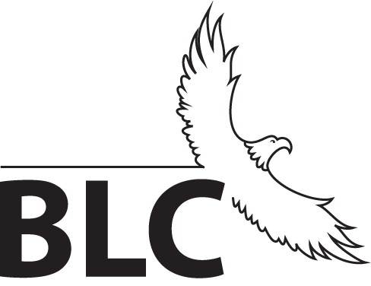

Please return completed forms to BLC at 129 - 12th St. Brandon AND
be prepared to complete 1-2 hours of initial assessment at that time.

Appointment must be made for registration involving special circumstance. Conditions of special circumstance include, but are not limited to:
- Learners under the age of 19 who have NOT graduated high school
- Learners dependent on the assistance of a support person/worker
- Learners with high school level programming designated as modified (M) or EAL (E)

BLC does NOT offer EAL programming.
You must be at least CLB level 5 and understand instruction in English to attend.

Please call (204) 729-9964 to schedule an appointment or to inquire about individual circumstances.

Registration Checklist
Registrations are only accepted when the following checklist is completely satisfied.
- 󠅠 Official high school transcript (if you have ever attended high school programming)
- 󠅠 Government-issued photo ID (driver’s license, passport, military card, status card, etc.)
- 󠅠 Completed registration form including writing sample (see reverse)
- 󠅠 Initial assessments, completed at time of submission (allow 1-2 hours to complete assessment)

Personal Information
Last Name: | First Name:
Previous Last Name (if relevant):
Date of Birth (mm/dd/yyyy):
Current Mailing Address:
City/Town: Province: Postal Code:
Phone Number: | Preferred Method of Contact:
Email Address: Do you want to be added to our email list?
Canadian Citizen: □ yes □ no If no, date arrived in Canada: ______ Is English your first language: □ yes □ no

Emergency Contact Information
Name: | Relationship: | Phone Number:

K – 12 Education
Last School Attended:
Last Year Attended: | Last Grade Completed: | Graduated: □ yes □ no
CLB Level (if applicable):

Other Education (university, college, training programs etc.)
Name: | Last Year Attended: | Completed: □ yes □ no
Name: | Last Year Attended: | Completed: □ yes □ no
Reason For Coming to BLC (Please choose ONE)
□ Improve reading, writing, and/or math skills for  employment/school/training etc. | □ Improve computer skills
□ College or university preparation | □ Take a short course offered at BLC
□ Get a high school diploma or mature student high  school diploma (MSHSD) | □ Other:
□ Take a high school credit course(s)
Please list course(s):

Writing Sample - Tell us about yourself (where you are from, what do you do etc.) and answer the following questions:
- Why are you coming to Brandon Literacy Council?
- What would you like to do in the future?
- Is there anything else about you that would be helpful for us to know?

